PROJECT REPORT

ON

PERSONAL PORTFOLIO WEBSITE

*Description*:

A personal portfolio website is a digital platform created by individuals, typically professionals such as designers, developers, artists, writers, or other creative professionals. It serves as a central hub to showcase their work, skills, achievements, and experiences to potential employers, clients, collaborators, or the general public.

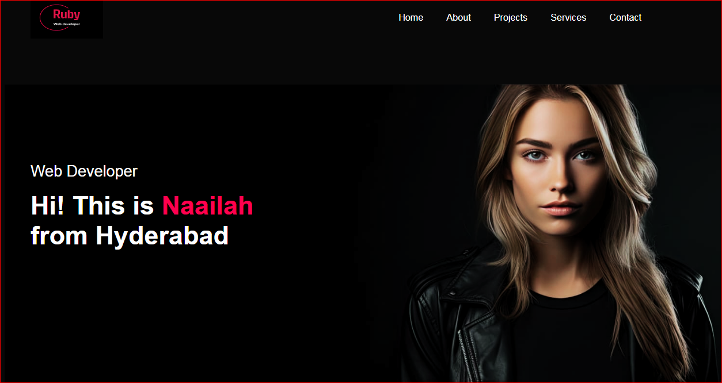

The homepage of my personal portfolio website.

**Table of Contents**

1. Introduction………………………………………………………………………..3
2. Objectives…………………………………………………………………………..4
3. Planning and Design………………………………………………………………..4
4. Development Process……………………………………………………………….4
5. Challenges and Solutions…………………………………………………………...5
6. Testing and Debugging……………………………………………………………...5
7. Results and Evaluation……………………………………………………………….5
8. View of the Website………………………………………………………………….6
9. Future Improvements…………………………………………………………………9
10. Conclusion…………………………………………………………………………….9

INTRODUCTION

The purpose of this project was to create a personal portfolio website to showcase my work, provide contact information, and improve my web development skills. This report covers the planning, development, and outcomes of the project.

**Basic Knowledge about web development:**

Web development is the process of creating, building, and maintaining websites and web applications that run on browsers. It involves front-end development (designing the visual and interactive aspects), back-end development (handling server-side operations and databases), and often includes tasks like web design, content management, testing, performance optimization, and SEO.

Web development includes several key components and activities:

1. Front-End Development:

- HTML: Structuring web content.

- CSS: Styling and layout of web pages.

- JavaScript: Adding interactivity and dynamic content.

2. Back-End Development:

- Server-Side Languages: Such as Python, Ruby, PHP, Java, and Node.js.

- Databases: Managing data with systems like MySQL, PostgreSQL, and MongoDB.

- Server Management: Configuring and maintaining web servers.

3. Full-Stack Development:

- Combining both front-end and back-end development skills.

4. Web Design:

- Creating the visual layout and user experience using design tools.

5. Web Content Management:

- Using CMS platforms like WordPress, Joomla, and Drupal to manage website content.

6. Testing and Debugging:

- Ensuring the website functions correctly across different browsers and devices.

7. Performance Optimization:

- Improving website speed and efficiency through techniques like image optimization and using CDNs.

8. SEO (Search Engine Optimization): - Enhancing the website’s visibility on search engines through best practices in site structure, content, and performance.

OBJECTIVES

The primary goals of this project were to:

* Create a visually appealing and user-friendly website.
* Showcase my projects and skills.
* Provide an easy way for potential employers to contact me.
* Improve my web development skills through practical application.

#### PLANNING AND DESIGN

#### Planning

* **Initial Planning**: Defined the project scope and timeline.
* **Content Outline**: Identified the main sections of the website (Home, About, Projects, Services, Contact).

**Design**

* **Outlines:** Created wireframes using HTML to outline the structure.
* **Styling**: Developed organized and visually appealing pages using CSS to make the website stylish and responsive.
* **User Interaction*:*** Developed dynamic user-interfaces using JavaScript and focused on the functionality and interactivity of the web pages.

### DEVELOPMENT PROCESS

#### Front-End Development

* **HTML**: Structured the content for each page.
* **CSS**: Styled the website with a focus on a clean and modern aesthetic.
* **JavaScript**: Added interactivity, such as form validation and animations.

### Technologies Used

* **Front-End**: HTML, CSS, and JavaScript.
* **Design Tools**: Font Awesome, Figma

### CHALLENGES AND SOLUTIONS

#### Challenges

1. **Responsive Design**: Ensuring the website looks good on all devices.
2. **Form Integration**: Handling form submissions and storing data.

#### Solutions

1. **Inspect element**: Utilized the “Inspect element” in Chrome for a responsive layout.
2. **Google Sheets**: Utilized Google Sheets application to store data regarding queries related to website.

### TESTING AND DEBUGGING

* **Functionality Testing**: Ensured all links, forms, and interactive elements work as expected.
* **Usability Testing**: Conducted user testing with peers to identify any usability issues.
* **Performance Testing**: Used Google PageSpeed Insights to optimize performance.
* **Cross-Browser Testing**: Verified the website’s functionality across different browsers and devices.

### RESULTS AND EVALUATION

The final product is a fully functional and visually appealing portfolio website. It includes a home page, an about page, a projects section showcasing my projects, a services page, and a contact form. User feedback was positive, noting the professional appearance and ease of navigation. Performance metrics showed the site loaded quickly and performed well across devices.

VIEW THE WEBSITE

HOME PAGE**:**

This page contains:

• A section with a professional photo, name, and a brief introduction.

• Call-to-action buttons (e.g., about, view projects, contact me).



ABOUT PAGE**:**

• Detailed bio with my background that is, education, experience, and hobbies.

• A profile picture of mine.

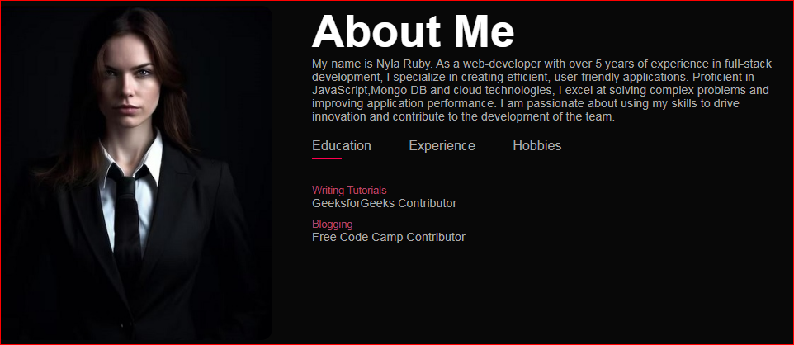

SKILLS PAGE:

* List of skills categorized by type (e.g., programming languages, tools, soft skills).
* Visual elements like progress bars or skill icons.

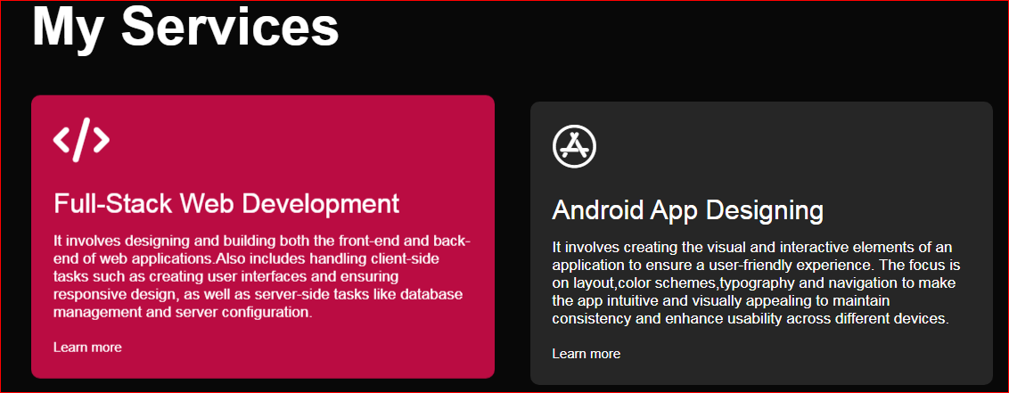

PORTFOLIO PAGE:

* Grid or list layout of project thumbnails.
* Individual projects with detailed descriptions, images, and links.

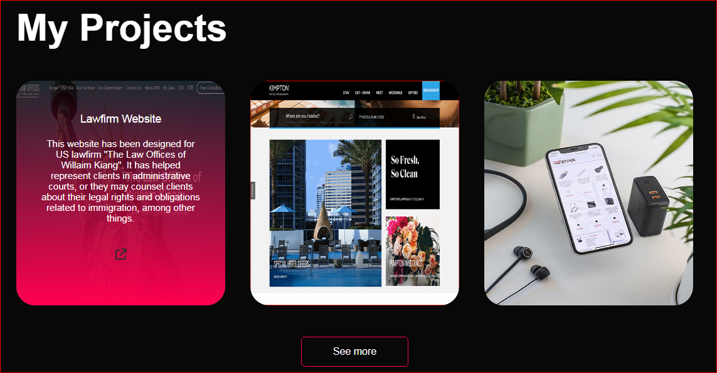

CONTACT PAGE:

* Contact form with fields for name, email, and message.
* Links to social media profiles.
* Links to resume/CV and downloadable PDF.

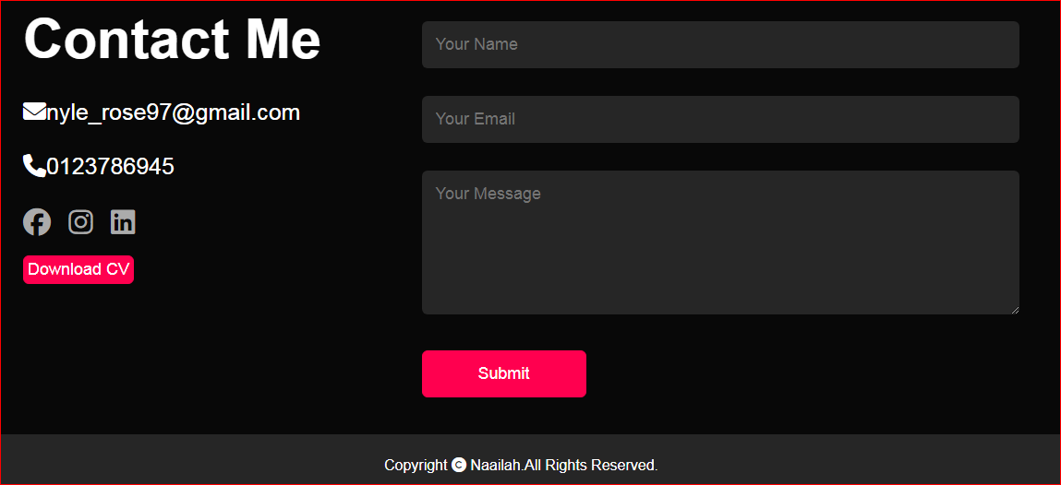

QUERY FORM:

* When a viewer has a query, they can enter their message in the form provided in contact section. The message along with the viewer’s email id and name will be stored in Google Sheets application.
* After the viewer has submits their query, a message reading “Message sent fully” is displayed.

RESUME/CV:

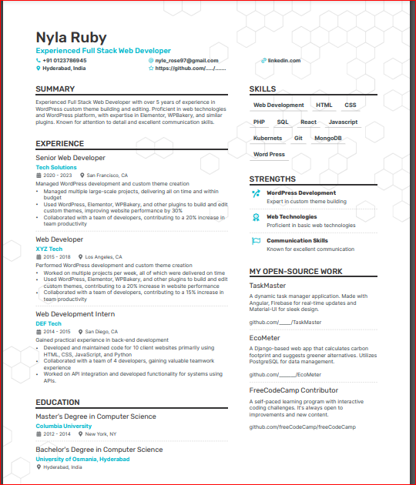

### FUTURE IMPROVEMENTS

* **Blog Section**: Add a blog to share insights and tutorials.
* **Advanced Animations**: Implement more advanced animations to enhance user engagement.
* **SEO Optimization**: Further optimize the site for search engines.
* **User Analytics**: Integrate Google Analytics to track user interactions and improve the site based on data insights.

### CONCLUSION

This project successfully met its objectives, providing a platform to showcase my work and improve my web development skills. The experience enhanced my knowledge in front-end development, as well as design principles.